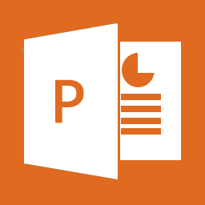
What’s New in Office 2013? PowerPoint Presenter View ______________________________________________________
CurrCurricu
Curn
Presenter View allows you to see your notes on your monitor while your audience sees only the slide. In previous releases of PowerPoint, it was difficult to figure out who saw what on which monitor. The improved Presenter View fixes that problem and makes it simpler to work with.
The Microsoft website has a great collection of free animated templates. Choose one of the free templates to download and practice the presentation view skills.

Microsoft Office Templates
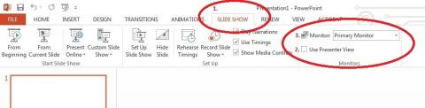
If everything is set up correctly, when you click Slide Show (bottom right), or press F5 on the keyboard, Presenter View opens by default. If you don’t want your slide show to be in Presenter View, simply uncheck the box located on the slide show tab.
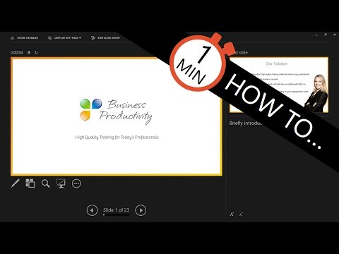
Presenter View looks like a stylish control panel for presenters. It allows you to see the current slide, complete with Notes, and also a preview of the next slide so you can prepare for it. View the video below for a short tutorial.

