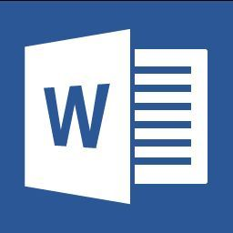
What’s New in Office 2013? Edit PDF Content in Word ______________________________________________________
CurrCurricu
Curn
Now you can grab any content you want from a PDF and open it in Word 2013.

Examples of Use:

Modify PDF documents from the Elementary Curriculum Framework for students that need differentiated support.

Save the following example PDF on your desktop. Open Word and Click on File>Open. Choose computer and navigate your desktop. Double click on the file and choose OK when the converting prompt appears. You can now edit the document.
- Example Assessment

Convert a PDF file in Word 2013 by clicking File > Open and selecting a PDF file. Word opens the content in a new file.
How PDF Reflow works
Opening a PDF in Word allows you to copy the content you want—including images and diagrams.
When you copy content directly from a PDF file and paste it into Word, the pasted text doesn’t have any formatting. PDF Reflow reconstructs the original layout elements in a Word document where it’s easy to copy, paste, and change content.
Which documents work best with PDF Reflow?
PDF Reflow works best with documents that are mostly text, such as legal, business, and scientific documents. That’s because it’s optimized to interpret a document’s text layout (including lists, tables, and columns).
If a PDF contains mostly images and diagrams, such as a presentation or a brochure, it might not reflow into Word as expected.
Why doesn’t the converted document look exactly like the original PDF file?
Because PDF Reflow converts the original PDF file into a Word file, some things might change. For example, the pages might break differently from the original PDF.
What happens when PDF Reflow does not detect an element?
Undetected elements appear as plain text or inside a text box. If the element is a chart or a diagram, it might get converted into points on a grid or a bitmap image.
For instance, if PDF Reflow doesn’t detect a footnote, the note text might appear as plain text right after its note reference mark, instead of at the bottom of the page, and it won’t be linked to the note reference mark.

