STORYBIRD

Storybird is an online service that lets children and adults write stories by writing their own text and inserting premade illustrations. They can create separately or in partners or small groups, then they can share their stories privately or publicly. Students can even collaborate on a story from across the country.
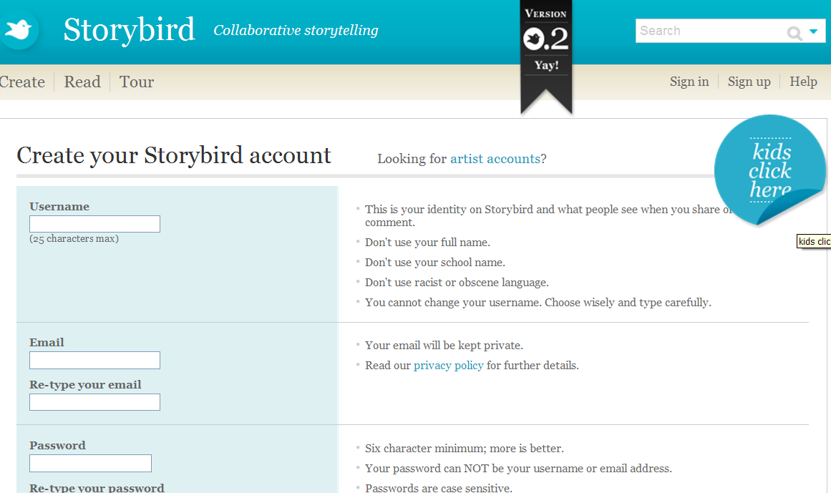
Click on “Sign up” in the top right corner to register for an account.
Follow the instructions in the Sign up sidebar. In particular, choose a username carefully. You can’t change it.
Once you click “Create your account,” you’ll be sent an email to confirm your registration. Be sure you add us to your safe list and check your spam filter if you don’t see our email.
You’ll be able to start using Storybird once you’ve activated your account. (Actually, you can read Storybirds without an account.)

Children's accounts
Click here to sign up. If you’re over 13, you can use the standard account.

Your account
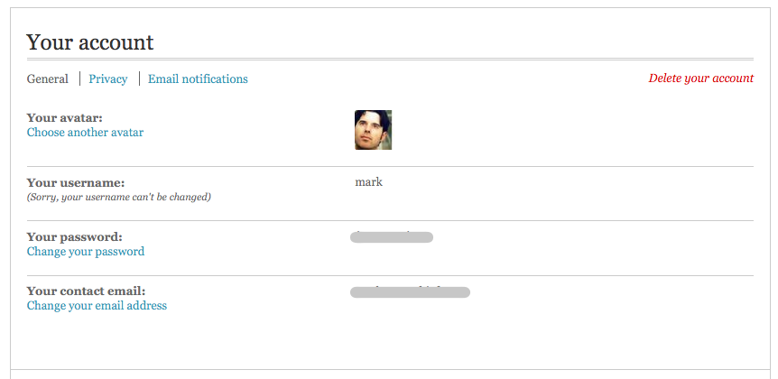
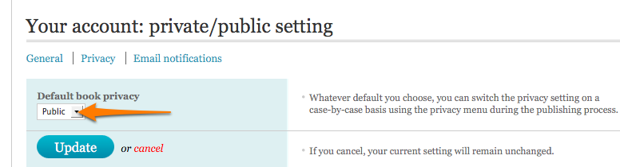
Once you’ve logged into Storybird you’ll find your account details by clicking on your username between the word “Hi” and “Logout” in the top right corner.

After you click your username, you’ll see the account panel:

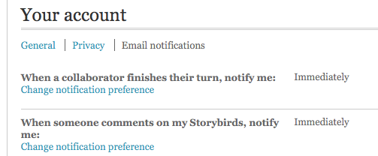

In the “General” settings, you can update your avatar, password, and email (usernames can’t be changed). You can also delete your account at any time (careful—it’s permanent).
Clicking the “Privacy” link enables you to change your privacy settings.
Your Storybirds default to “Private.” This means that while you can make and share Storybirds, they won’t show up in the public library/timeline.
Choosing “Public” from the pull-down menu resets the default, so ALL your Storybirds are made public. However, these are just the defaults: you can change the Public/Private settings for each Storybird on a case-by-case basis.
“Email Notifications” settings help you control how often we tell you about comments on your Storybirds or when a collaborator switches turns with you.
Both are set to “Immediately” and both can be reset:

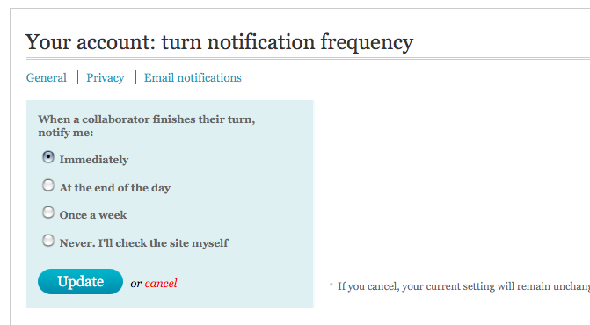
Your profile
Storybird doesn’t ask for or display personal information about you. Not your age, location, or interests. Here, your shared stories represent you to the community.

If you decide to make your Storybirds private, then your experience is anonymous. No public profile whatsoever.
Click on your avatar to see your public profile.

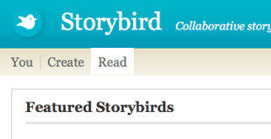
Finding Storybirds
Click on the “Read” link in the main navigation to reach the public library/timeline. This is where all publicly shared Storybirds live.

Reading, commenting on, and hearting Storybirds
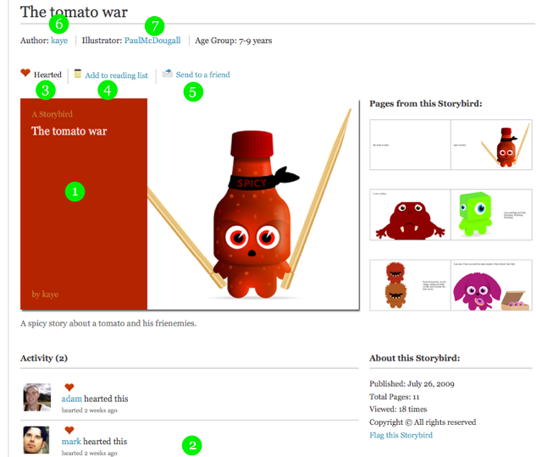
Each Storybird has a unique page where it lives. If the page is private, only you and those you invite can see it. If it’s public, everyone can see it.
Here are some of the things you can do on a Storybird page:
- Read a Storybird: click anywhere on the cover.
- Comment: scroll below the cover and use the comment box.
- Heart a Storybird: click the heart icon.
- Add to your reading list: click the link.
- Send to a friend: click the link.
- Link to the author: click the name(s) beside the author tag.
- Link to the illustrator: click on the name(s) beside the illustrator tag.

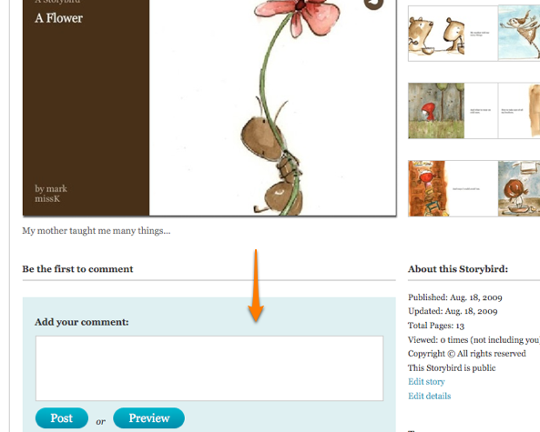
Comments
You’ll find the comment box below the Storybird cover as you scroll down the page.
You can preview your comment and, once posted, edit it up to 15 minutes later.
If one of your Storybirds receives a comment you don’t like, simply used the “Delete” link beside it.

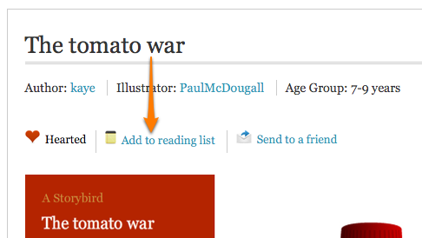
Reading lists
Any public Storybird can be added to your reading list. Simply click the “Add to reading list” link above the book.
You’ll find a link to your reading list in links beside your avatar on your homepage. To remove a Story bird from your reading list, navigate to the story’s main page and click the “Remove” button on the menu next to “In my Reading List”.

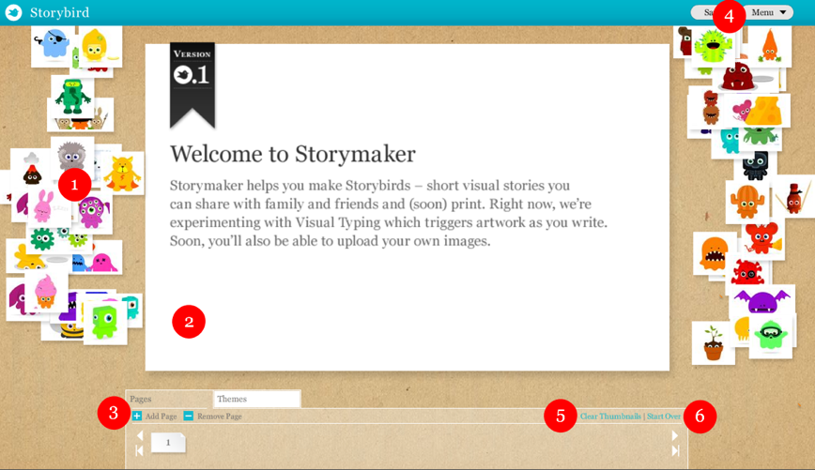
Using Storymaker
Storymaker is the engine that helps you make Storybirds. The best way to understand it is to use it or to watch our demo. Otherwise, here are some basics.
- Pictures: drag art thumbnails onto the page.
- Words: mouse over the white page and start writing.
- Pages: add or delete pages using these controls.
- Menu: invite a collaborator, publish, or save and close.
- Clear thumbnails: removes all thumbnails but leaves pages.
- Start over: removes all pages and thumbnails.

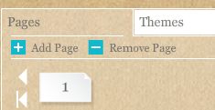
Making a cover Storymaker automatically creates a cover for you after you add your first image to a page. When you start, your page menu looks like this:

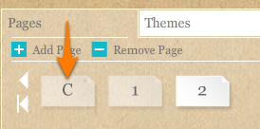
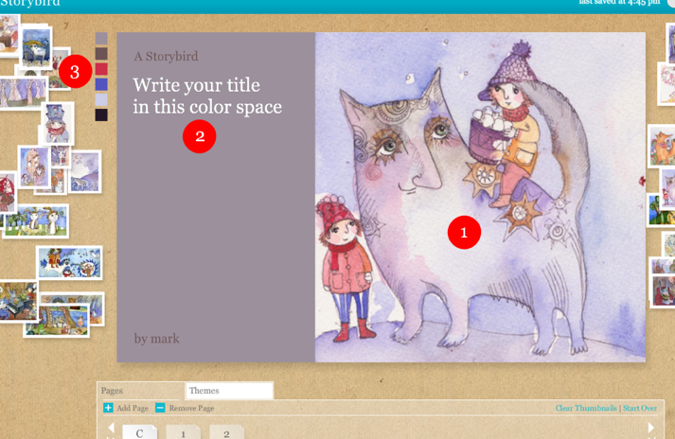
After you’ve added some art to your pages, you’ll notice a new page icon labeled “C” in your page menu. That’s your cover. Click it.

Here’s an example of a cover and how you customize it:
- Cover art: usethis, or replace it with another art thumbnail.
- Title: write your title in this area.
- Title color: click the color squares to choose color.

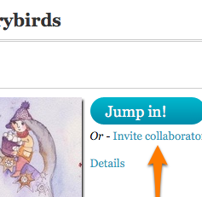
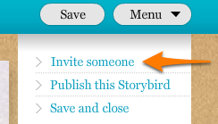
Inviting a collaborator
Storybird is extra-fun when you work with friends or family. You can invite a collaborator in two places.
From the menu in Storymaker:
And from your dashboard:
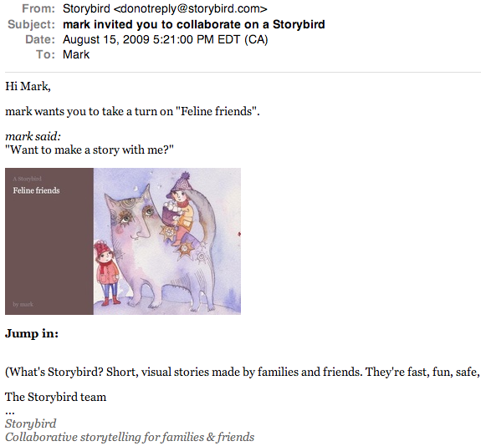
Click the “Invite” link and fill in the invite form. Your collaborator will get an email that looks like this:
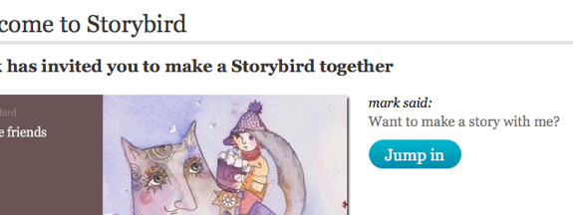
When your collaborator clicks on the link they’ll be taken to an invite landing page where they can jump in and start playing:

You can jump in and make changes to a Storybird anytime you want. But to make things easier we assign turns and notify you on your dashboard and by email when your partner has taken their turn or is switching turns with you.

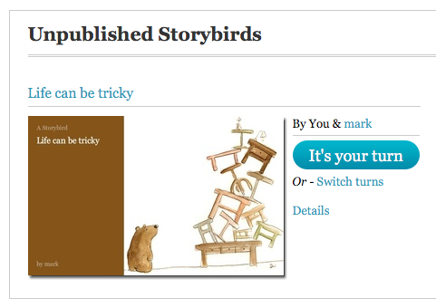

Publishing Storybirds
When you (or your partner, if you’re collaborating) want to finish and publish your Storybird, choose “Publish” from the Storymaker menu…

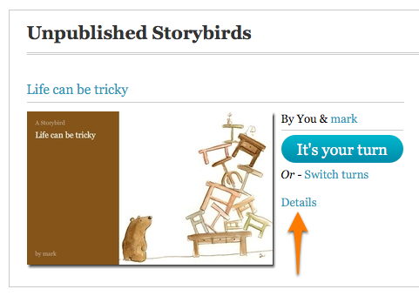
…or click the “Details” link beside the cover on your dashboard:

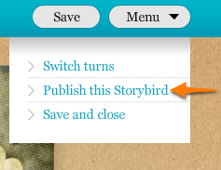
Choosing “Publish” or clicking “Details” will take you to the “About this Storybird” panel where you can include details about your story, set your privacy option, and publish it.
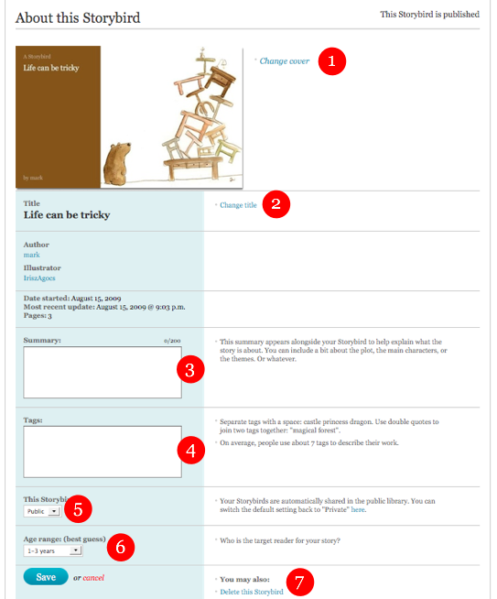
Here’s what’s on the page:
- Change cover: Don’t like the cover? Change it.
- Change title: Same as above—change it if you want.
- Summary: Your story’s “flap copy” or synopsis.
- Tags: Keywords that describe your story.
- Privacy: Public or private option.
- Age range: Who’s the story most suited for?
- Delete: Don’t like it? Throw it away.
You can change all of these at any time—even after you publish.

Public/Private settings
Storybirds can be set to public or private on a story-by-story basis. Just toggle the privacy menu in the “About this Storybird” panel.
Remember, you can also set the default to public or private in your account settings. That way your preference will always be used each time you publish a Storybird, even if you forget.
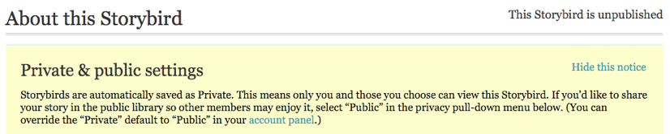
And, when you publish your first Storybird, we also insert this reminder onto your page about how to manage privacy.
Tags help you manage your Storybirds and make it easier for everyone to find them (if you make them public).
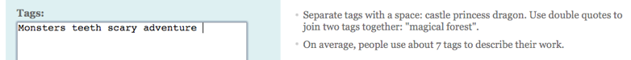
You can add tags to your Storybird in the “About this Storybird” panel when you publish or update your story.

These tags will appear on your published Storybird page and become active links to other stories with the same tags.

Making changes
You can make changes to your Storybirds even after they’re published. This includes the story itself and the details about the Storybird.To make changes, simply navigate to the Storybird page and click on “Edit story” or “Edit details.”

Deleting or opting-out of Storybirds

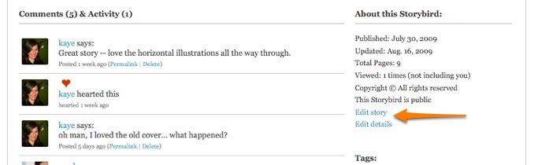
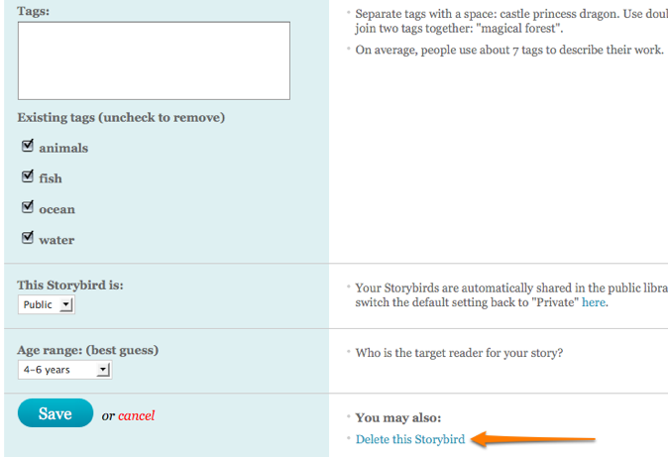
Storybirds made by one author can be deleted at anytime. Click on the “Details” link of your Storybird and scroll to the bottom. You should see a “Delete this Storybird” option. Clicking it will take you to a confirmation page where you can delete the story or cancel and return to the information panel.
Storybirds made with two collaborators have some conditions.
1. Before the Storybird is published, the originating author— the person who started the story and invited a collaborator— can delete it whenever they choose. Follow the instructions above. However, the collaborator—the person who was invited—can NOT delete it. They can “Exit” or “Opt out,” which removes them from the Storybird.
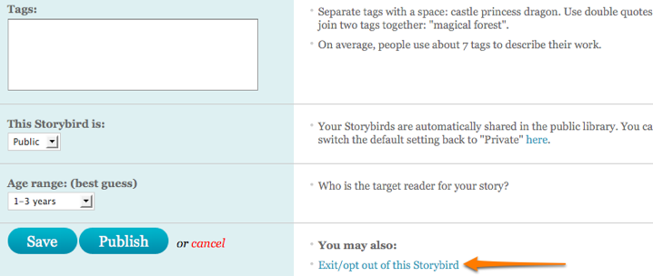
To Exit/Opt out of a Storybird, scroll down to the bottom of the “Details” page where you’ll see “Exit/Opt-out of this Storybird.” Click on the link and follow the instructions.
2. After a Storybird is published, both the originating author and the collaborator can ONLY Exit/Opt out. But once one party exits, the other can delete it. In other words, both collaborators have to agree to delete a Storybird after it’s published.

Is Storybird safe?
We designed Storybird to be as safe as possible for kids and their families.
First, we are NOT a virtual world. There is no chat engine built into Storybird, so there’s no way for your child to have a real-time conversation with anyone.
Two, Storybird does NOT create public profile pages for members that reveal their interests, locations, phone numbers, etc.
Three, Storybirds can be made private and only shared among people you choose. If you want, you and your kids can have a completely anonymous experience. That said, we encourage everyone to publicly share their Storybirds since sharing doesn’t reveal private information and makes the public library better and better.
Finally, all Storybirds that are shared publicly are reviewed for offensive or inappropriate content before appearing in the library. If we find inappropriate material, the Storybird is pulled. It’s that simple. And if we miss something, any Storybird can be flagged for immediate review.

Flagging a Storybird or art
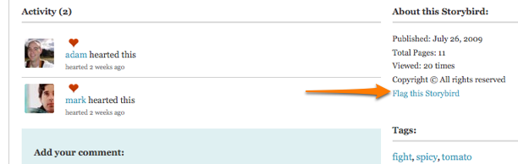
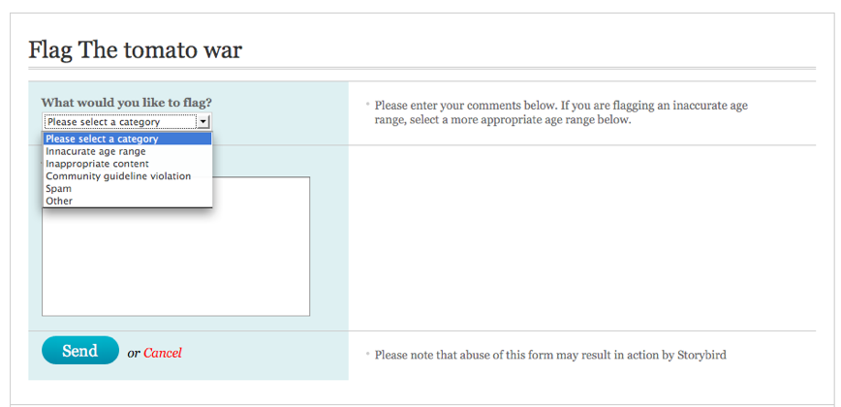
Each Storybird page or art page can be flagged for inappropriate content, spam, or general violations of our community guidelines. You can also use it to suggest a more appropriate age range for the item. You’ll find a “Flag this Storybird” or “Flag this art” in the bottom right-hand corner of the page.

Once clicked, you’ll see a report form where you can select a category and add notes about why you’re flagging the item and where it’s located on Storybird (the page address/URL).
Be specific and concise with your report. But also be mindful. Abusing this feature can result in actions by Storybird.

Reporting abuse

The “Report Abuse” form can be found in the footer of every page on Storybird. Use it when you want to report inappropriate content, community guideline violations, spam, or other general concerns.

