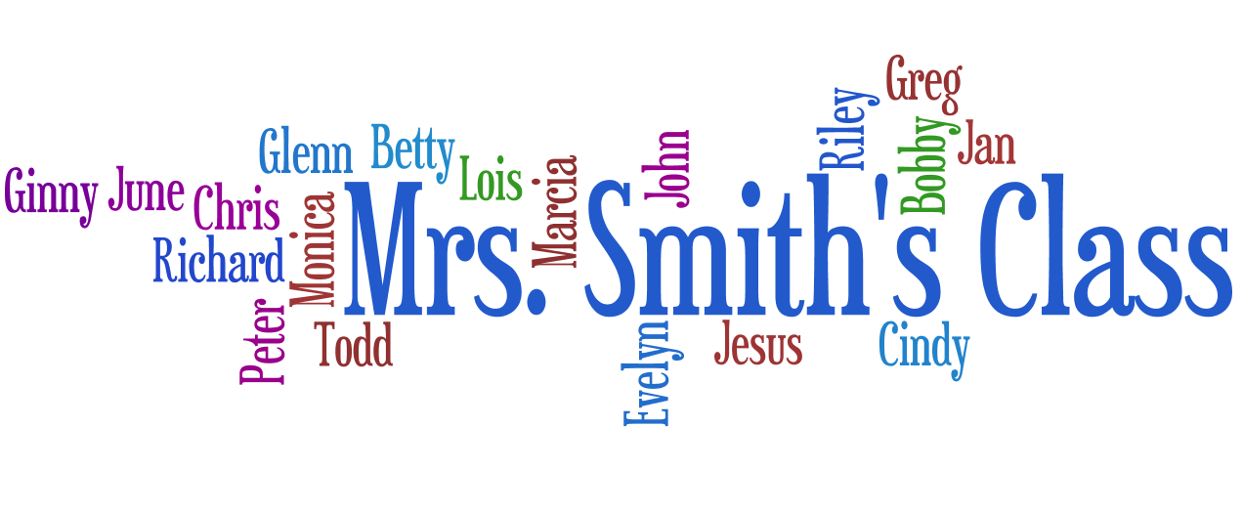
W
ordle is a toy for generating “word clouds” from text that you provide. The clouds give greater prominence to words that appear more frequently in the source text. You can tweak your clouds with different fonts, layouts, and color schemes. http://www.wordle.net/
Tips on using Wordle
- Type your words into a Word document so you can make changes if needed.
- If you want a word(s) to appear larger, type the word once and copy/paste it several times.
- If you want some of your words to be grouped together, use the tilde symbol (~) between the words. Example: Mrs.~Smith’s~Class
- Once you type the words you want, copy the text and go to www.wordle.net. Click Create and then right-click in the text box and select paste. Then click Go. Once the “wordle” is created, you can click Randomize until you find the style you like. Use the toolbar at the top to customize the font, color, etc.
How can I use Wordle in my classroom?
- Word Chunks: (i.e. –an pan, man, fan, etc.)
- All About Me or All About My Family
- Character Traits/Analysis- Type name of a character or famous person and attributes that describe him/her.
- Synonyms (for those over used words students use when writing)
- Cover of a class book (Type title and then add authors’ names.)
- Vocabulary/Terminology
- Word Poetry
- Reflections
- Parts of Speech
- Figurative Speech
- Phonics
- Rhyming Words
- Characteristics of Genres
- Mind Mapping
- Descriptive Writing
- Living/Nonliving
- Forms of Energy
- Earth Forces
- Weather
- Math Factors
- Fact Families
- US Constitution
- Biographies (Inventors/Famous Americans)
- American Revolution
- Math Concepts
- Renewable/Nonrenewable/Inexhaustible Resources
- Facts about a certain topics (i.e. Indians, biomes, animals, habitats, Solar Systems, States, holidays, etc)
The sky is the limit with this application!

